To create an app in Erpnext 12 developer mode

navigate to frappe-bench file then use this command

1- bench new-app <app-name>

for example

bench new-app Demo-app

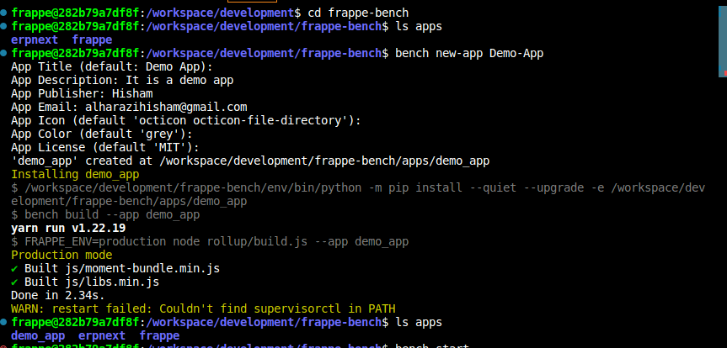

2- install the new app to ERPnext Site

bench install-app <app-name>

for example

bench install-app demo_app

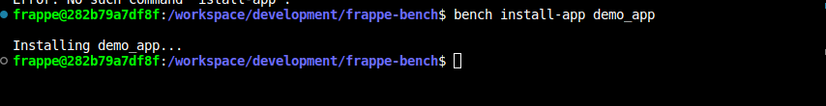

then check the new if dose exist in Erpnext Desk

Desk page > Help > About

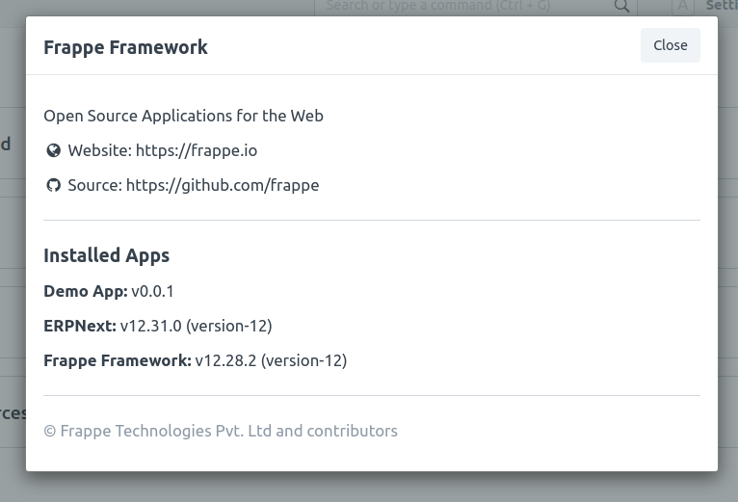

3- open VS code there u can check the new app files

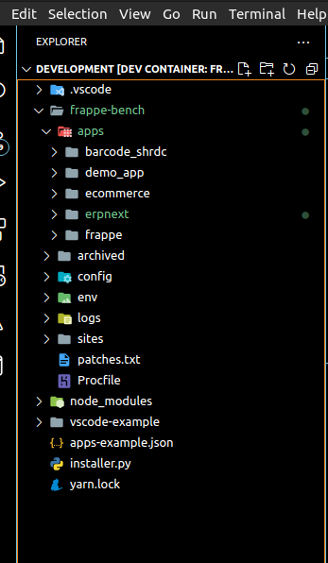

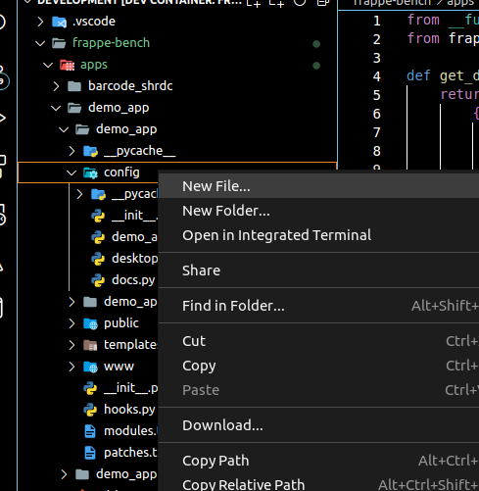4- open the new app folder then in config folder create new file.py name it anything

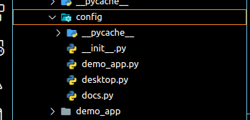

5- create the DocType in that file using the function get_data()  
  
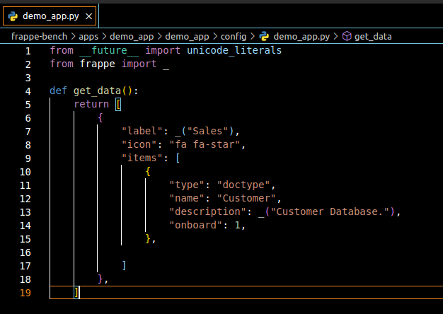for example   
getting the Customer DocType

6- Add the file name to the desktop.py to be shown in desk page

{

"module_name": "demo_app", file name

"color": "grey",

"icon": "octicon octicon-file-directory",

"type": "module",

"label": _("Demo App") label name

}

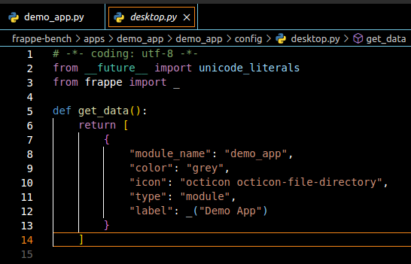

7- Add the file name to the modules.txt

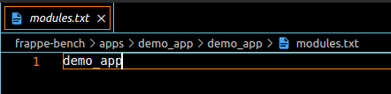

Now you can check the desk page by reload it

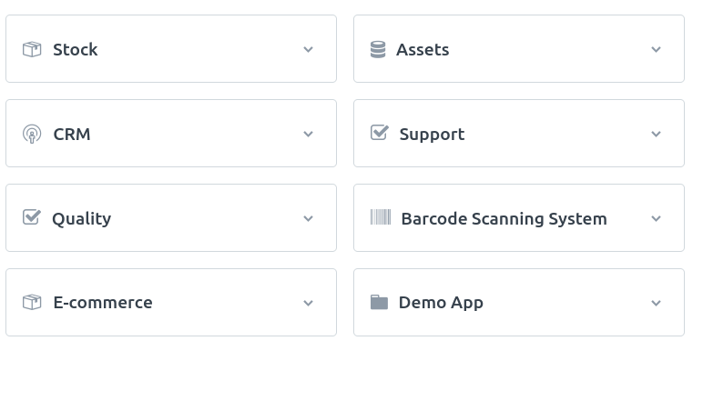

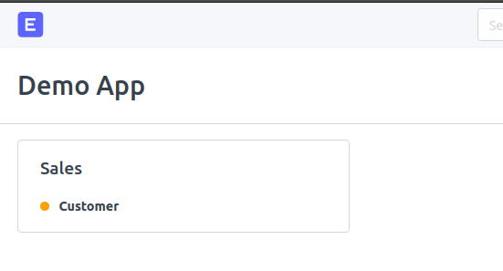Step 5 result